**Project Design Phase-II**

**Data Flow Diagram &User Stories**

|  |  |
| --- | --- |
| Date | 03October 2022 |
| Team ID | PNT2022TMID46892 |
| Project Name | Project - Developing a Flight Delay Prediction Model using Machine Learning |
| Maximum Marks | 4 Marks |

**Data Flow Diagrams:**

Example: DFD Level 1 (Industry Standard)

**Example:** 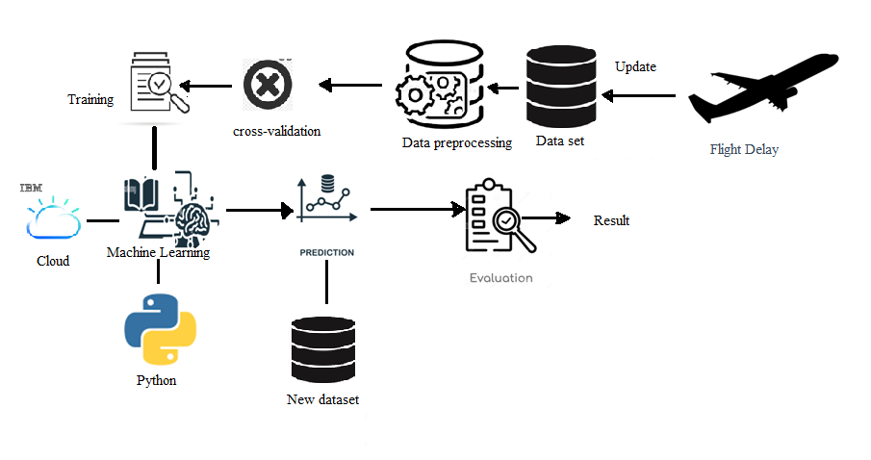

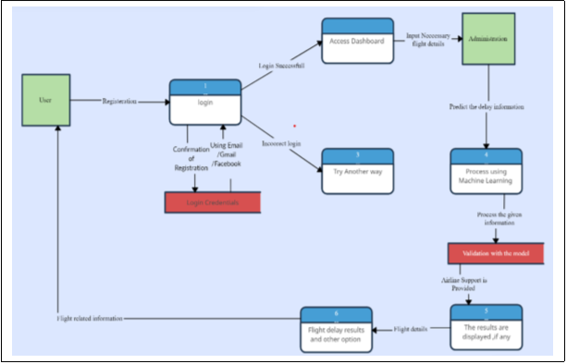

**User Stories**

Use the below template to list all the user stories for the product.

| **User Type** | **Functional Requirement (Epic)** | **User Story Number** | **User Story / Task** | | **Acceptance criteria** | **Priority** | **Release** |
| --- | --- | --- | --- | --- | --- | --- | --- |
| Customer (Mobile user) | Registration | USN-1 | As a user, I can register for the application by entering my email, password, and confirming my password. | | I can access my account / dashboard | High | Sprint-1 |
|  |  | USN-2 | As a user, I will receive confirmation email once I have registered for the application | | I can receive confirmation email & click confirm | High | Sprint-1 |
|  |  | USN-3 | As a user, I can register for the application through Facebook | | I can register & access the dashboard with Facebook Login | Low | Sprint-2 |
|  |  | USN-4 | As a user, I can register for the application through Gmail | | I can register through Gmail | Medium | Sprint-1 |
|  | Login | USN-5 | As a user, I can log into the application by entering email & password | | I can login into the application by using email and password | High | Sprint-1 |
|  | Dashboard | USN-6 | As a user, I can able to access the dashboard after successfully login | | I can access the dashboard after login | High | Sprint-2 |
| Customer (Web user) | Registration | USN-1 | As a user, I can register for the application by entering my email, password, and confirming my password. | | I can access my account / dashboard | High | Sprint-1 |
|  |  | USN-2 | As a user, I will receive confirmation email once I have registered for the application | | I can receive confirmation email & click confirm | High | Sprint-1 |
|  |  | USN-3 | As a user, I can register for the application through Facebook | | I can register & access the dashboard with Facebook Login | Low | Sprint-2 |
|  |  | USN-4 | As a user, I can register for the application through Gmail | | I can register through Gmail | Medium | Sprint-1 |
|  |  | USN-5 | As a user, I can log into the application by entering email & password | | I can login into the application by using email and password | High | Sprint-1 |
| Customer Care Executive | Airline Support | USN-1 | As a user ,I want to contact the customer care whenever I find a need | | I can contact the customer care easily and services are also provided quickly | High | Sprint-3 |
| Administrator | Data processing and prediction | USN-1 | | As a user, I want to predict and analysis the data correctly to provide the results | I can receive the results accurately and precisely | High | Sprint-4 |